Tactile Feedback on Flat Surfaces for the Visually Impaired

Visual impairment Tactile feedback Surrounding

【Main Content】：

In this paper we introduce a mobile, generic, and inexpensive visuo-tactile sensory substitution device for the visually impaired. The device helps users to explore the world around them, by pointing it towards objects of the environment and rendering tactile information to the objects sensed by a camera. With the help of two visually impaired participants, we conducted three preliminary experiments and evaluated the performance of the device in detecting, reaching and exploring tasks.

【Experiments】：

Apparatus：

Touch screen, camera, TeslaTouch

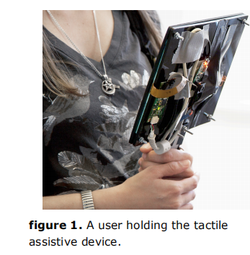 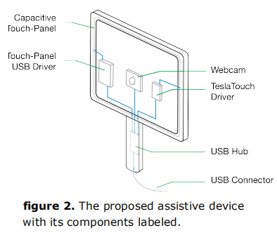

Experimental premise:

The procedures for all three experiments were similar. The experiments were performed in an empty room, 15 feet 6 inches wide by 13 feet 4 inches deep. Participants held the prototype tactile device with one hand and scanned the room by sliding the index finger of the other hand on the touch screen.

**E1：detecting the object** (The participant detects the object (red square wood) placed in front of him, and the task of the participant is to report whether they feel the presence of the object. Where objects are detected, they also point to their location on the touch screen.)

Procedure：

Participants sat on a chair in front of an empty white table. The device was clamped to the table to ensure that the camera was always covering the same area of the table. A square red piece of wood was used as an object. Each participant was tested in 40 trials. During half of the trials, the object was placed in a random location in front of the device. During the other half of the trials, no object was placed on the table. Trials with or without the object were also randomized in order. The task for the participant was to report whether they felt the presence of the object or not. In the cases where an object was detected, they also pointed to its location on the touch screen. Participants’ response and trials times were recorded.

Conclusion：

Detection task is quite simple for participants.

**E2：detecting, reaching and lifting the object** (Whether participants can perform the tasks of detecting, reaching, and picking up objects.)

Procedure：

The setup of Experiment 2 is the same as Experiment 1, except that participants can move the device freely during the mission. Participants were instructed to detect the object on the tablet and pick it up when they felt it was close enough to the object.

Conclusion：

Average completion time for S1 was 16.9 seconds, and for S2 it was 45.6 seconds. S2’s data suggest a prominent learning curve.

**E3：finding the trashcan** The goal of Experiment 3 was to test whether participants were able to locate and reach for an object in a room. Participants’ mobility was thus less constrained, and they were able to move freely in the room.

Procedure：

The task consisted of finding a blue recycling bin in the room and dropping a ball in it. This bin was placed randomly along one of the walls of the room. Another bin, a “distractor” of the same size, but black in color, was also placed in the room to create confusion for the participants. Each trial started with participants standing in the middle of the room.

Conclusion：

Analysis of the recorded data showed that participants could find a recycling bin in 5 minutes using conventional or device-based technology. The average completion time using the recommended assistive device is 42 seconds.

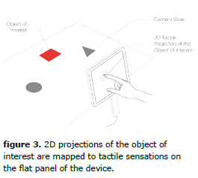 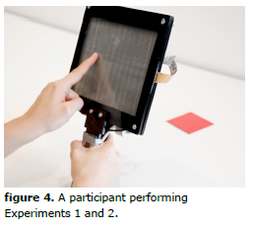 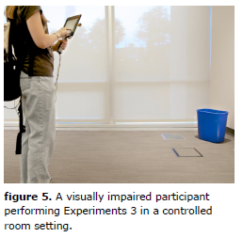

【Subjective analysis】：

Advantage:

1) Developed a technology based on color detection and mapping to haptic feedback.

2) Simultaneous equipment cost

3) The experiment was carried out in a progressive form

4) Great help for visually impaired people to detect objects

Disadvantages:

1) Limitation lies in identifying by color only

2) The equipment is bulky

Next：

1. Edge, contour, contrast
2. Miniaturization of equipment such as integration into mobile phones, suitable for complex environments such as outdoor

【Future tasks in paper】:

However, the limitations of devices and technologies are not limited to color detection and haptic rendering. Currently, we are exploring the best strategies to extract various features such as edges, contours, contrast, etc. and use haptics to present them. Our goal is to develop a vision for tactile mapping that can have an impact in complex real-life environments and to help people with disabilities every day.

【Important Reference】:

[1] Bach-Y-Rita, P., Collins, C. C., Saunders, F. A., White, B. and Scadden, L. Vision Substitution by Tactile Image Projection. Nature, 1969, 221 (5184). pp. 963-964.